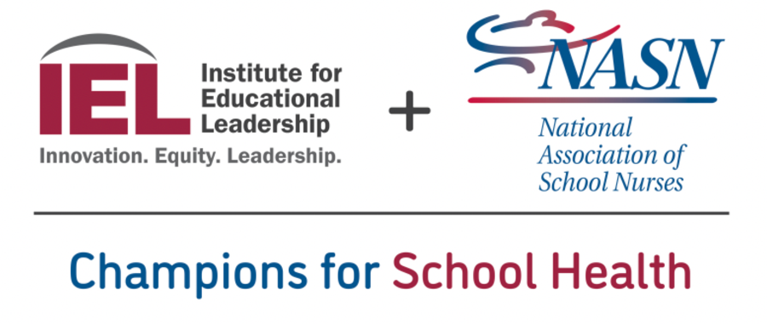
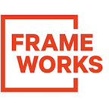

Want to Build Vaccine Confidence?
Help Us Help You
In partnership with the National Association of School Nurses and Institute for Educational Leadership, the FrameWorks Institute is designing a toolkit to equip school-based staff to communicate more effectively with families about the COVID-19 vaccine.

We’re asking for about three minutes of your time
to help improve the toolkit.

Please scan the QR code below or use the link to access a short survey.

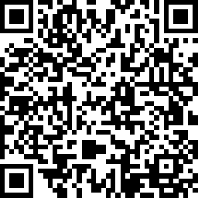

https://www.surveymonkey.com/r/NASNFrames

Thank you for your assistance and insights!

